My Project
Peru

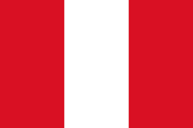

Eoin Doyle

Peru
It is in south America.
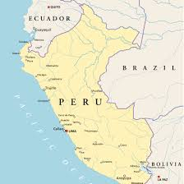

Brazil and Chile are Peru’s neighbours.

The flag is Red, White and Red.

It has cold winters and heavy rainfall but is also sunny in the summer.

The capital is Lima.
They speak Spanish.

31.2 million people live in Peru. Manchu Picchu is Inca buildings , it is in the mountains.

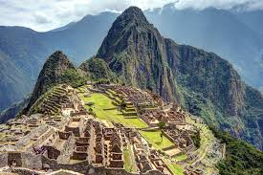
Lots of tourists go there.
It is also called the Lost City of the Incas.

The condor bird is a famous bird in Peru.
It is the biggest bird in Peru.
It is a big, black bird.
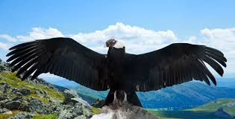

Some day I would like to visit Machu Picchu.

